REPORT FOR: | Pensions Board
Date of Meeting: | 30 October 2023
Subject: | London CIV and Investment Pooling Update
Responsible Officer: | Sharon Daniels – Interim Director of Finance and Assurance
Exempt: | No - except for Appendices 1, 2 and 3 which are Exempt from publication under paragraph 3, Part 1 of Schedule 12A to the Local Government Act 1972 (as amended) as each of these contains information relating to the financial or business affairs of any particular person (including the authority holding that information)
Wards affected: | List Ward(s) affected by decision.  None
Enclosures: | Appendix 1 – Exempt - LCIV Quarterly ACS Report to 30 June 2023  Appendix 2 –Exempt - LCIV Quarterly Private Markets Report to 31 March 2023  Appendix 3 – Exempt – LCIV Annual Review to 31 March 2023

Section 1 – Summary and Recommendations
This report provides an update for the Board on the current position on Investment Pooling and the LB Harrow Pension Fund’s own pooling arrangements with the London Collective Investment Vehicle.

Recommendations:
The Committee is recommended to consider and note the report.

Section 2 – Report

- The LGPS (Investment and Management of Funds) Regulations 2016 set the framework within which LGPS pension funds are required to manage their investments. They are required to have an Investment Strategy Statement (ISS) – which sets out how the Fund will manage and invest its assets to enable it to meet its Funding Strategy. The Regulations require funds to include in the ISS how they will approach pooling of investments and use collective investment vehicles. Each Fund is required to be a member of a pool.

- The Government’s long term objective is that Funds should work towards a position where all LGPS investment assets are managed via pools – with Funds setting the Strategic Asset Allocation (i.e. deciding on what classes of investments Funds should be allocated - e.g. equities, bonds, etc - and whether they should be managed passively or actively) while the pools will select the asset managers within each category. To this end, the Statutory Guidance on Preparing and Maintaining an Investment Strategy Statement (issued in 2016) states that “from 2020, funds should only make new investments outside of a pool in very limited circumstances”.

- The London Collective Investment Vehicle (LCIV) was set up by the London Boroughs in their roles as administering authorities for their respective pension funds. LCIV enables the various Funds to meet the Government’s requirements for pooling of investment assets. From the Harrow Pension Fund’s perspective, the scale of investments which LCIV oversees enables it to achieve two main benefits.

- the lower level of fees which CIV has negotiated,
- access to certain asset classes (e.g. Infrastructure, renewables infrastructure) which a Fund of Harrow’s size may not be large enough to access cost effectively on its own.

- Additionally, during 2021 and 2022, LBH has decided to replace two of its equity managers because of poor investment performance, and the availability of suitable managers / investment vehicles within LCIV removed the need for a specific manager selection exercise and hence reduced our costs and shortened the implementation timetable considerably once the investment decision had been made.

- The London CIV, whilst owned by the London Boroughs’ Pension Funds, is regulated by the Financial Conduct Authority as an investment manager, and accordingly is required to meet the various regulatory and governance requirements of the FCA. LCIV does not manage the underlying investments directly – rather it has appointed a range of Fund managers in the various asset classes to do that.

- LCIV has a monitoring framework against which each underlying manager is monitored, which includes reviewing the managers’ investment performance, fee levels, asset allocation (to ensure that they are investing in line with the agreed mandate), and approach to ESG matters, including voting and engagement activity.

- At 30 June 2023, LCIV had over £13.9 billion of assets under management, and a further £2.5 billion of commitments in respect of the various “Private Markets” funds. Their current fund range includes:
- 8 global equity funds (in addition to the passive funds which are held outside of the CIV)
- 1 emerging markets equity fund
- 4 multi asset funds
- 3 Fixed income funds (2 MAC, 1 Global bonds)
- 1 Infrastructure fund
- 1 Renewables Infrastructure fund
- 1 Private Debt Fund
- 1 Private Markets
- 2 property funds

- In addition, a number of new Funds are currently under development.

- For regulatory / FCA purposes, most LCIV Funds fall within the Authorised Contractual Scheme (ACS) Structure – this includes the equity, fixed income and multi asset funds. Each investment mandate with LCIV is a separate ring-fenced sub fund within the ACS. The remaining funds are “Private Markets” Funds. These tend to be illiquid.

- The fund development process includes “seed investor groups” from London Borough Pension Funds which may be interested in the investment being considered. The purpose of these groups is to ensure that mandate development follows a direction which the client funds require and hence will invest in. It is possible to participate in these groups to gain an understanding of how the mandate will develop before deciding or committing to invest. Consequently, officers have participated in a number of these groups, and will continue to do so where these are considering investments likely to be of interest to LBH.

- LCIV’s staffing team continues to evolve – the most significant recent change is the resignation of Chief Investment Officer Jason Fletcher. The new Chief Executive, Dean Bowden has been meeting the Pension Fund Committee Chairs and Lead Officers of each Boroughs to understand their needs and requirements.

- As reported elsewhere on this agenda, at 30 June 2023 LB Harrow had 49.4% of its investments in LCIV funds, and a further 29.3% in passive funds which are counted as being pooled because the fee arrangements were negotiated by LCIV. Once commitments to the LCIV Renewables Infrastructure Fund and the LCIV Infrastructure Fund are fully called, this will increase the total of investments pooled or counted as pooled to 82%.

- LCIV’s most recent update and performance reports on its investments are enclosed as follows:
- Appendix 1 – Quarterly ACS Report to 30 June 2023
- Appendix 2 – Quarterly Private Markets Report to 31 March 2023 (the illiquid nature of these investments and the more complex valuation process where these are “unlisted” means that the reporting cycle is slower than the more liquid ACS funds.
- Appendix 3 – Annual Review for year ending 31st March 2023

- These appendices are Exempt as they contain commercially confidential information – hence if Board members wish to discuss these in detail, they can do so in Part 2.

- A key objective from pooling was to generate savings for client funds through reduced fees payable to managers. The most recent calculation of fee savings (to 31 March 2023) can be seen in the table below and also on page 27 of the attached appendix 3 – exempt. Again, if Board members wish to discuss this in detail they can do so in Part 2.

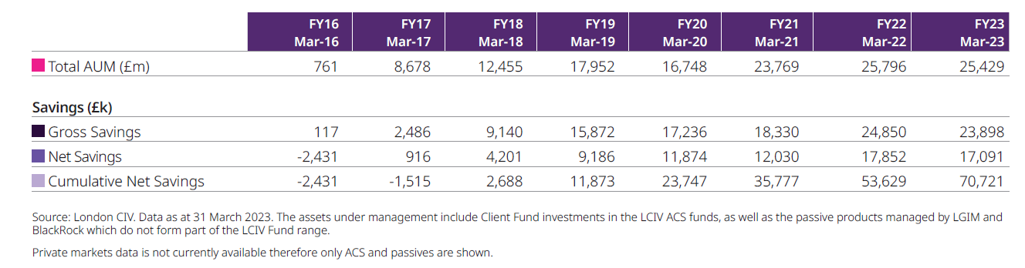

- The above cost savings in the Annual review isn’t at client fund level. LCIV use the quarterly cost savings reports sent to clients to build the overall figures. The indicative savings for each quarter for Harrow are shown in the table below:
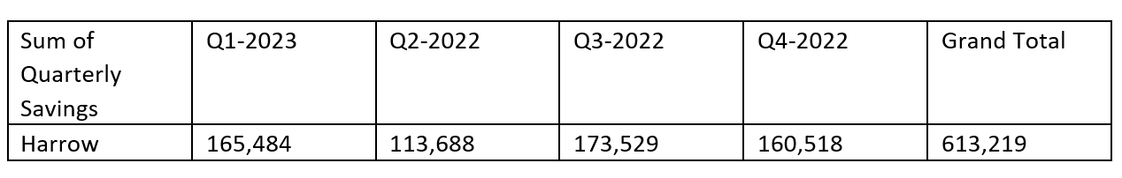
- Finally, LCIV is increasing its work in respect of ESG matters – including holding managers to account in respect of their work on voting and company engagement. LCIV will also be a key part of the LBH Fund’s ability to meet its Climate Reporting Requirements (TCFD) in due course.

Legal Implications

- There are no direct legal implications arising from this report.

- The terms of reference for the Board include the Board’s role as set out in the following paragraphs.

- The role of the Board, as defined by sections 5(1) and (2) of the Public Service Pensions Act 2013, is to assist the Administering Authority (London Borough of Harrow) as Scheme Manager in ensuring the effective and efficient governance and administration of the Local Government Pension Scheme (LGPS) including:

- securing compliance with the LGPS regulations and other legislation relating to the governance and administration of the LGPS;
- securing compliance with requirements imposed in relation to the LGPS by the Pensions Regulator; and
- such other matters the LGPS regulations may specify.

- The Administering Authority retains ultimate responsibility for the administration and governance of the scheme. The role of the Board is to support the Administering Authority to fulfil that responsibility.

- In its role, The Board will have oversight of the administration of the fund including:

- The effectiveness of the decision making process
- The direction of the Fund and its overall objectives
- The level of transparency in the conduct of the Fund’s activities
- The administration of benefits and contributions

- The Board will provide the Scheme Manager with such information as it requires to ensure that any Member of the Board or person to be appointed to the Board does not have a conflict of interest.

- The Board will ensure it effectively and efficiently complies with the Code of Practice on the Governance and Administration of Public Service Pension Schemes issued by the Pensions Regulator. It will help to ensure that the Fund is managed in the same way.

- The Board shall meet sufficiently regularly to discharge its duties and responsibilities effectively.

Financial Implications
- Whilst the performance and effective controls of the fund managers is of paramount importance in the performance of the Pension Fund, there are no direct financial implications arising from this report.

Risk Management Implications
- Risks included on corporate or directorate risk register? No
Separate risk register in place? Yes

- The Pension Fund’s Risk Register is reviewed regularly by both the Committee and the Pension Board.

- There are no specific risk management implications arising from this report. The level of risk to which its investments are exposed is a key component in developing the Fund’s investment strategy.

Equalities implications / Public Sector Equality Duty
- Was an Equality Impact Assessment carried out? No
There are no direct equalities implications arising from this report.

Council Priorities
- The performance of the Pension Fund directly affects the level of employer contribution which then, in turn, affects the resources available for the Council’s priorities.

Section 3 - Statutory Officer Clearance

Statutory Officer: Sharon Daniels
Signed by the Chief Financial Officer
Date: 19 October 2023
Statutory Officer: Sharon Clarke
Signed on behalf of the Monitoring Officer
Date: 16 October 2023
Chief Officer: Sharon Daniels
Signed on behalf of the Chief Executive
Date: 19 October 2023

Mandatory Checks

Ward Councillors notified: Not Applicable

Section 4 - Contact Details and Background Papers
Contact: Bola Tobun – Treasury and Pensions Manager
Email: Bola.Tobun@harrow.gov.uk
Telephone 020 8420 9264

Background Papers: None

